MC900078791[1]**2021 HIGH SCHOOL SENIOR SCHOLARSHIP APPLICATION**

**If you have attended Head Start in one of our CNCAP (Central Nebraska Community Action Partnership) service areas, you have the opportunity to apply for the following scholarship:**

* **Central Nebraska Community Action Partnership - Mary Dusek Head Start Graduate Scholarship** (2 Local CNCAP Scholarships-$250 each). Only applicants who attended a Head Start program in CNCAP’s service area will be eligible for this cash award.) **Deadline for this scholarship is January 4th 2021(See attached application)**

This scholarship targets individuals who reflect the values of hard work, educational determination and leadership.

**Award specific criteria**:

* The nominee must have attended Head Start for one or more years in a CNCAP service area.
* The nominee must be scheduled to graduate from High School, be pursuing a post-secondary education, and submit name of institution of higher education that they are enrolled in or have the desire to attend. These funds may be applied to the documented cost of tuition, and or books.

**Include in application**:

1. **BIO** - Please share key details about yourself and your family, connection to Head Start and current educational environment. (30 points)

The nominee must submit responses for each of the following categories, in their entirety. Maximum point value for each category is indicated in parentheses. Judges will rate specific information.

1. **Special contributions**: Describe activities contributed by the student to the local Head Start program or community as a volunteer. (30 points)
2. **Educational goals:** The applicant should write a statement of personal goals no more than 200 words in length. (20 points)
3. The nominee must submit two letters of reference.  Attach letters of reference from two people who know the nominee as a student (school personnel preferred), and as a member of or volunteer in the community. **Please have them address their letters to the Scholarship committee** as the letters of references will be utilized for all of the awards if chosen. Judges will rate the overall effectiveness of the letters. Applications that do not include two references will not be considered for this award. (20 points)
4. Submit attached cover page and email or enclose **"head shot" photograph.** Enclosed photos will be returned.

* Applicant must be willing to allow CNCAP to publicize their nomination through a variety of media channels including annual publications and websites.

If you have questions please contact Peg Knapp at 308 745-0780 ext. # 114.

Map denotes current **Central Nebraska Community Action Partnership service area**. Stars mark Head Start Center locations.

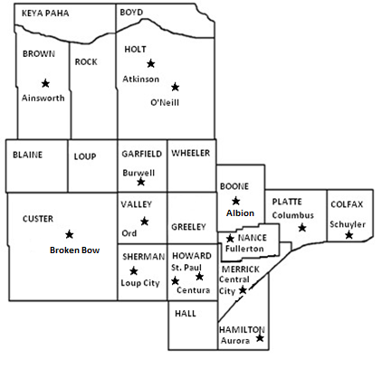

**Cover page - Central Nebraska Community Action Partnership Head Start Graduate Scholarship**

Date:

Name:

Mailing Address:

City: State: Nebraska Zip Code:

Phone: E-mail:

High School currently attending:

Expected date of graduation:

Name of Head Start Program attended:

City:

Institution of Higher Education that you are enrolled in or have been accepted to:

Name:

Address:

Field of Study:

Attach or email ([pknapp@centralnebraskacap.com](mailto:pknapp@centralnebraskacap.com) ) a “head shot” photo.

Mail completed application to:

**CNCAP**

**Attn: Peg Knapp**

**PO Box 509**

**Loup City, NE 68853**

**308 745-0780 ext 114**

**Applications must be post marked by January 4th 2021**