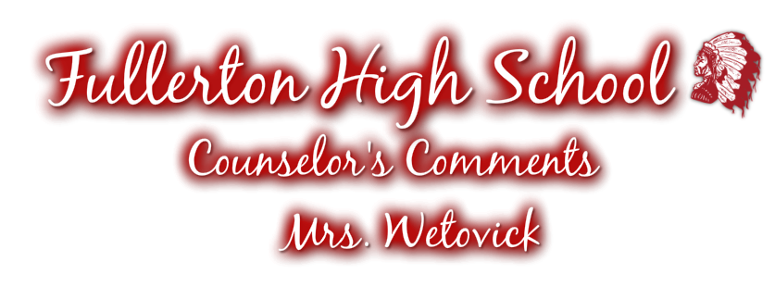

Fullerton High School - Junior & Senior - Students & Parents!

October is filled with many important and sometimes “scary” adventures for Juniors & Seniors and their parents in terms of college and vocational planning. There are school campuses to visit, ACT exams to take, applications to begin filling out and appointments with college representatives to make! Be sure to keep up on what is happening!

REMEMBER: There are three ways in which I will be communicating important information:

- Counselor’s Comments- Monthly Newsletter Sent to Your Home
- Student Announcements- Located on PowerSchool
- My Website- http://mrswetovick.weebly.com - you can access my website directly or by visiting my page on the FPS website.

SENIORS: It is time for you to begin applying to college! I will be hosting an Apply2College Campaign in my room during the whole day on October 23rd. This can be conveniently done during Independent Study and Student Aid periods. If you do not have either one of these classes in your schedule you need to make an appointment with Mrs. Wetovick! This designated day is a great opportunity for me to sit down with you and help you APPLY2COLLEGE!

Please read this newsletter closely and feel free to contact me with questions
or concerns by e-mail @ jordan.wetovick@gmail.com or
call me at 308-536-2431.

Mrs. Wetovick

OCTOBER “TO DO” LIST:

JUNIORS & SENIORS:

- Schedule campus visits
  - The only way you will truly know if you can “see” yourself at a particular college is to go “see” the campus and visit with the college representatives.
  - As always, there are applications in Mrs. Wetovick’s room!

- Visit with college representatives when they visit FHS!
  - Sign up in Mrs. Wetovick’s room.

- Attend a College Fair this Fall!
  - Before you attend a college fair, register for a barcode at NebraskaCollegeFairs.org. Check out my website for a list of college fairs under the College Info. tab.

- Register by November 6th for the December 12th ACT

- Register by October 9th for the November 7th SAT
  - Some out of state colleges request SAT scores- Please contact Mrs. Wetovick for SAT information if needed.

SENIORS:

- Apply to your top 3-4 colleges before the deadline.
  - FHS is hosting an Apply2College event in October- This will provide you an opportunity to complete your college application during the school day and get help from Mrs. Wetovick!

- Narrow your college choices down to 2-3, no more than 4.

- Take the ASVAB on October 26th from 8:55 a.m. – 12:10 p.m.

JUNIORS:

- Take the PSAT on October 14th from 8:55 a.m. – 12:10 p.m.
ACT

Below are the 2015/2016 ACT testing dates. Juniors, it’s time to start thinking about taking the ACT and seniors, it’s crunch time to either get your first score to send to colleges or boost your current scores! Each student has the opportunity to obtain a hard copy of this information located on my bulletin board. Test Fee: $39.50. Sign up today at www.actstudent.org!

Test Date | Reg. Deadline | Late Reg.
Oct. 24 | Sept. 18 | Sept 19-Oct. 2
Dec. 12 | Nov. 6 | Nov. 7-20
Feb. 6 | Jan. 8 | Jan. 9-15
April 9 | Mar. 4 | Mar. 5-18
June 11 | May 6 | May 7-20

COLLEGE FAIRS

EducationQuest is hosting a college fair at the Pinnacle Bank Expo Center in Grand Island from 1:00-3:00 p.m. on Sunday, October 11th. College fairs are a great place to hear about numerous colleges all in one convenient place!

COLLEGE VISITS

Reminder: Juniors and seniors are allowed to take a total of 4 college visits total over a 2 year time period. Juniors can take up to two (2) days their junior year and seniors are allowed to take up to three (3) days to visit college campuses.

College visits MUST be set up with Mrs. Wetovick after filling out a college visitation form located in her office. Make sure all schoolwork is made up in ADVANCE. Mrs. Wetovick will have make-up slips available for you. They will be handed in to Mrs. Wetovick, BEFORE leaving on the college visit!
RHOP

The Rural Health Opportunities Program is designed to address the special needs of Rural Nebraska by encouraging rural students to pursue a career in health care fields in rural Nebraska. If selected, you will receive a tuition waiver from the selected college (Wayne, Chadron, Peru State or UNK) and a guaranteed admission to the University of Nebraska based upon successful completion of your pre-professional studies during your undergraduate experience, appropriate GPA and exemplary conduct. Incoming freshmen should apply NO LATER than NOVEMBER 15th! Applications are located on my website!

SENIOR ASVAB

On Monday, October 26th, the seniors will be taking the ASVAB test, which is administered by the Armed Forces. This test not only is the qualifying test for the military, but also gives the students a different type of test that also measures vocational skills as well as academic skills. This test is required for all seniors as part of our overall testing program. As always, if you have any questions, please let me know!

APPLY2COLLEGE CAMPAIGN

This year, FHS is hosting an Apply2College Campaign on October 26th! Through this event, seniors will be provided with the opportunity to complete their college application during the school day and get one-on-one assistance from Mrs. Wetovick!
COLLEGE
REP VISITS

We have a number of college reps coming to visit FHS. Currently the following schools will be visiting in Room 104, my office/classroom during the school day. Sign up sheets are located in my office. It’s a great way to find out more about what colleges are offering!

Wayne State College- Thursday, October 8th @ 10:00 a.m.

Central Community College- Columbus: Monday, October 12th @ 11:45 a.m.

University of Nebraska- Kearney: Wednesday, October 21st @ 9:30 a.m.

Joseph’s College of Cosmetology- Monday, October 19th @ 11:00 a.m.

SCHOLARSHIP CENTRAL

Be sure to visit: http://mrswetovick.weebly.com to stay up-date with scholarship opportunities and deadlines. Mrs. Wetovick will update the website as soon as scholarships are available! The website will include a complete description of the scholarship, downloadable applications, as well as links to the websites. Be sure to check out DEADLINES for each scholarship and READ the QUALIFICATIONS in order to know if they apply to you or not. You can also come talk to Mrs. Wetovick about obtaining more information!

SCHOLARSHIPQUEST

Check out ScholarshipQuest sponsored by the EducationQuest Foundation. This website serves as a great supplement to my Scholarship Central website; click the link on my website. After creating a ScholarshipQuest account, you have access to a multitude of Nebraska-based scholarships!

REMEMBER, YOU CAN’T RECEIVE A SCHOLARSHIP IF YOU DON’T APPLY!

FINANCIAL AID

Thank you to all parents and students who attended the FAFSA (Free Application for Federal Student Aid) informational meeting on Monday, September 28th at Parent Teacher’s Conferences. The FAFSA application will be open January 1st. Most colleges require the FAFSA to be completed by April 1st in order to plan for the 2016-2017 school year. The Susan T. Buffet scholarship requires the FAFSA to be completed by March 15th. EducationQuest provides free services to help families fill out the FAFSA. There are opportunities to visit their offices in Kearney, Omaha or Lincoln. There are many changes this year, please let Mrs. Wetovick know if you need more information!

UNK Health Careers Fair

The University of Nebraska- Kearney is hosting a Health Careers Fair on Wednesday, October 14th starting at 8:30 a.m. An opening speaker, over 30+ representatives from various healthcare professions and an optional campus visit are included during this event. Go to visit.unk.edu for more information. Attending this fair would count as an excused college visit absence. Let Mrs. Wetovick know if you would like more information.

